**UGANDA CERTIFICATE OF EDUCATION**

**SENIOR TWO**

**HISTORY AND POLITICAL EDUCATION 241/1**

**TIME: 1 HOUR: 30 MINUTES**

**Instructions to learners**

* This paper consists of three examination items
* Attempt only two items
* Any additional item answered will not be scored
* All answers must me written in the items booklet provided

ITEM 1

The Royal tombs of Buganda at Kasubi were set on fire by unknown strangers and very many items were completely destroyed. The police and other security agencies made efforts to find out the actual cause of this fire but their efforts remained futile. Many Ugandans came up with arguments over this event that the tombs should be removed so that an industry is put up to provide employment to the people. However, UNESCO has insisted that the tombs should be renovated and maintained.

**Support material***: Front view of the Kasubi Royal tombs in Buganda as of 2012.*

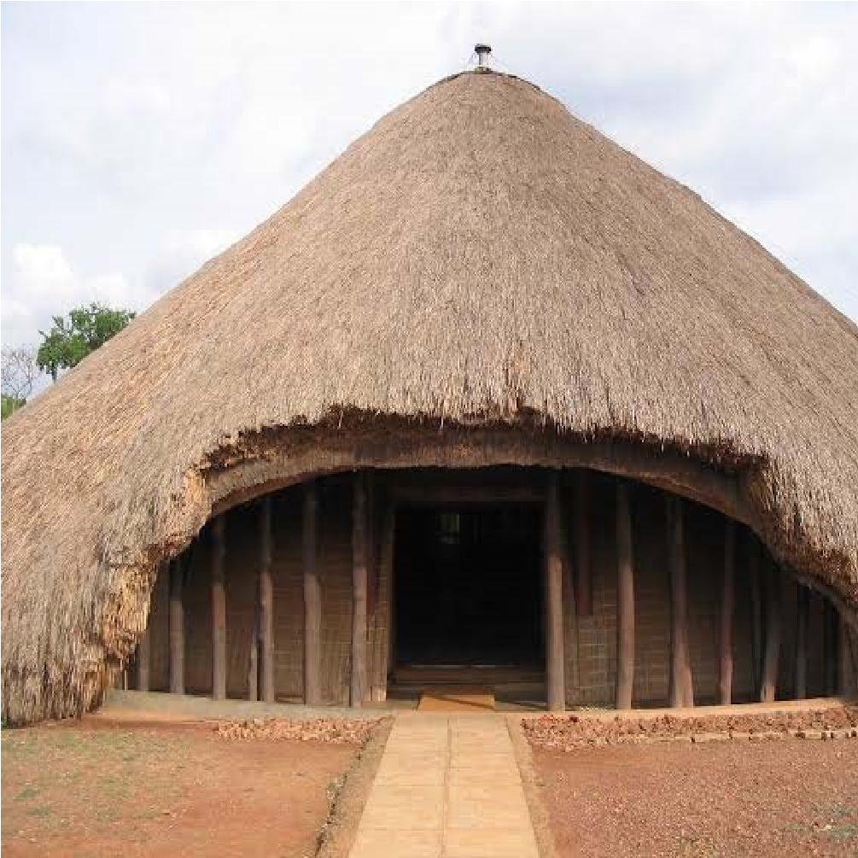

**Task:**

1. Support UNESCO’s idea.

ITEM 2

In Butebo village, there is a very educated wealthy man. One of his children of fended an elder of the village. As a result of this, the elders have resolved that the child be punished in their traditional courts, but the father insists that the matter be handled by the public court. This has angered the elders.

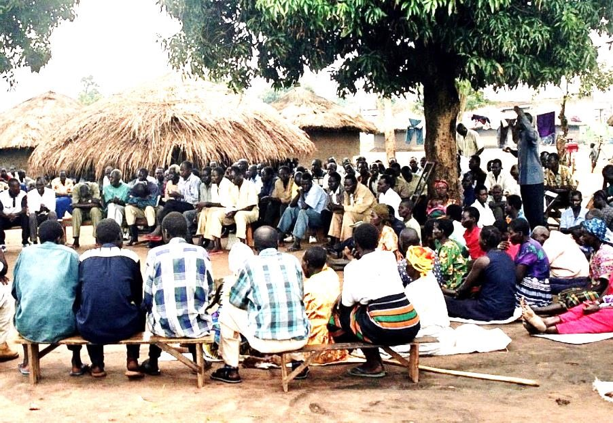

### A traditional village meeting

### Task

1. Write an essay convincing the educated wealthy man to accept the elder’s decisions.

**ITEM 3**

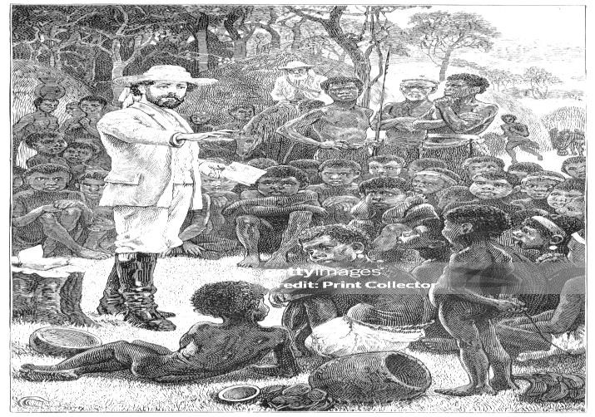A section of the people of Kalongo village are against activities of a Christian religious group from Germany. They petitioned the local government of the area to block its operations in their community citing challenges like noise pollution, fraud by pastors, and spread of gay-related activities among others. However, majority of the people in the area are of the view that despite the above challenges, religion plays a significant role in the development of the community as such, the Christian group should be left to carry out their activities.

**The white missionary preaching to a group of Christians.**

**Task:**

1. Write an essay to convince the people in Kalongo to welcome the activities of the Christian group.

**ITEM 4**

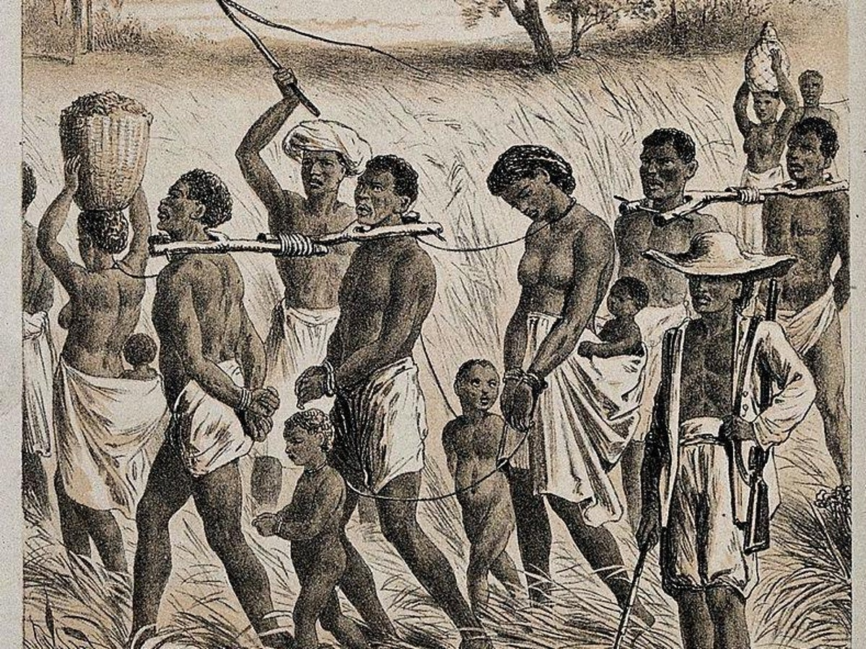During the history lesson in S.2 class, an argument broke out regarding the influence of slave trade in east Africa during the 19th Century. Some learners argued that the activity was entirely negative to the people of East Africa, while some mentioned that it was beneficial to some communities despite its negative effects . You have been invited to talk to the S.2 class about the topic in question.

**Task**

1. Make a write up that you will use when talking to the class.

**END**